Deployed Network Evidence
This document shows that the Innovatech network has been built and is running on AWS in the eu-central-1 (Frankfurt) region.

1. Architecture Overview
The network uses two VPCs connected by a Transit Gateway. The DMZ VPC is the only part that faces the internet. It holds the public subnets for the load balancer and the NAT gateway. The Internal VPC has no direct internet access. It holds the web servers, the database and the monitoring stack, each in its own subnet.
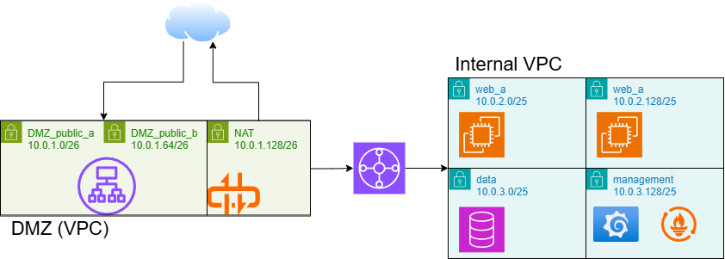
Figure 1: Network design: DMZ VPC and Internal VPC connected by the Transit Gateway

2. VPCs and Subnets

2.1 DMZ VPC (Terraform)
The DMZ VPC uses 10.0.1.0/24. It has two public subnets in different availability zones (eu-central-1a and eu-central-1b) so the load balancer stays up if one zone fails. It also has a separate subnet for the NAT gateway. The Internet Gateway is attached here, which makes this the internet-facing edge of the network.
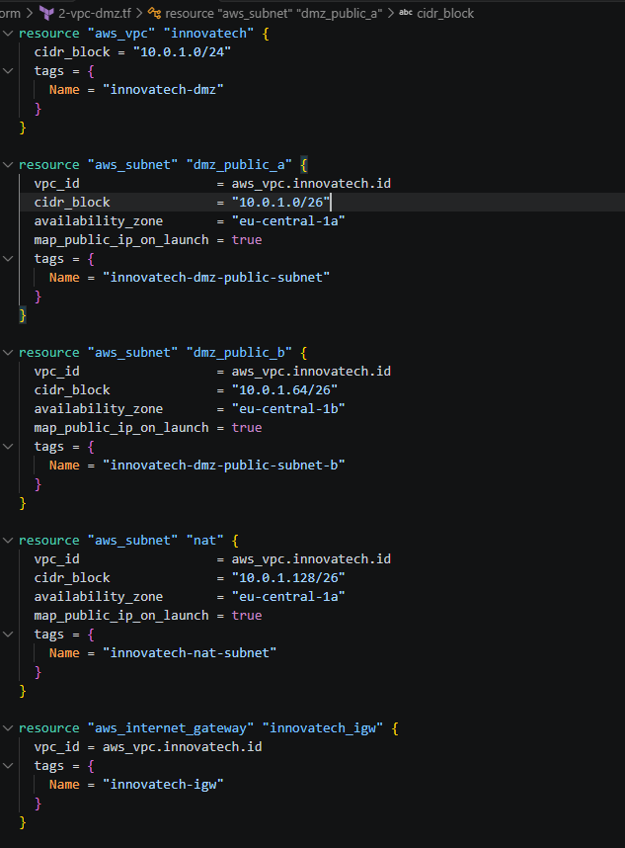
Figure 2: 2-vpc-dmz.tf: DMZ VPC, public subnets, NAT subnet and Internet Gateway

2.2 Internal VPC (Terraform)
The Internal VPC uses 10.0.2.0/23 and is split into four /25 subnets, one per tier: two web subnets across both availability zones, one data subnet and one monitoring subnet. None of these subnets gives out public IP addresses, so nothing in this VPC can be reached directly from the internet.
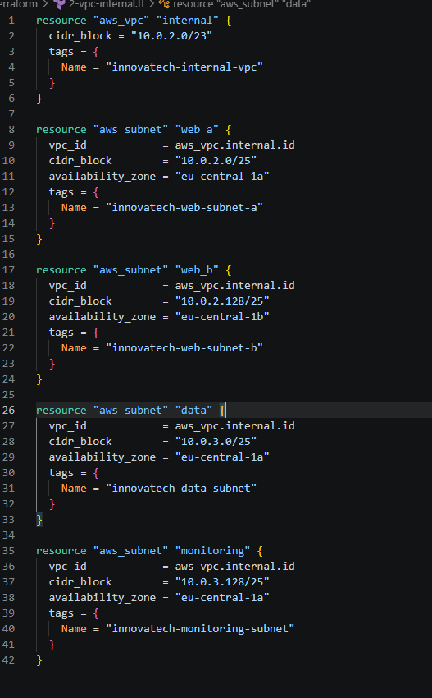
Figure 3: 2-vpc-internal.tf: Internal VPC with web, data and monitoring subnets

2.3 Deployed VPCs and Subnets (AWS Console)
The console shows both VPCs as Available, with the same CIDR ranges as the code.
Figure 4: AWS console: innovatech-dmz (10.0.1.0/24) and innovatech-internal-vpc (10.0.2.0/23)
The deployed subnets match the Terraform definitions and are all Available. The list also includes innovatech-tgw-attach-subnet (10.0.1.192/26), a small subnet in the DMZ VPC that the Transit Gateway attaches to.
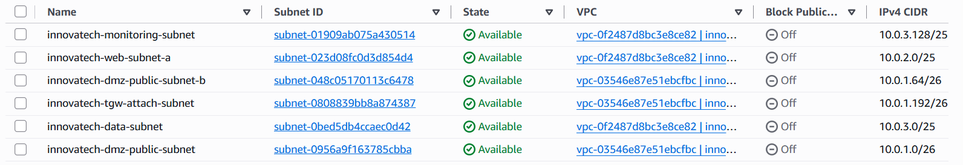
Figure 5: AWS console: deployed subnets with their VPC and CIDR ranges

3. Internet Access

3.1 NAT Gateway
Servers in the Internal VPC sometimes need to reach the internet, for example for software updates and package downloads. The NAT gateway allows this. It sits in the DMZ NAT subnet with a fixed Elastic IP address and only allows outbound connections, so the internet cannot start a connection to the internal servers. The depends_on line makes Terraform create the Internet Gateway before the NAT gateway.
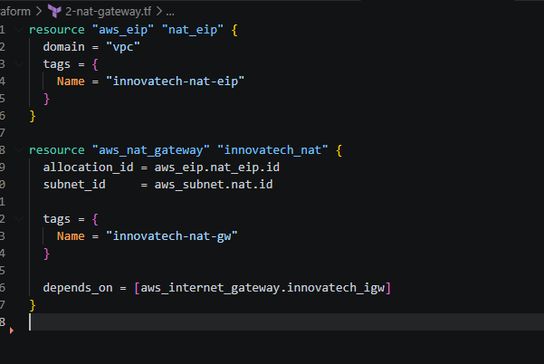
Figure 6: 2-nat-gateway.tf: Elastic IP and NAT gateway
Figure 7: AWS console: innovatech-nat-gw is Available with public connectivity

3.2 Internet Gateway
The Internet Gateway connects the DMZ VPC to the internet. The console shows it as Attached to the VPC.
Figure 8: AWS console: innovatech-igw attached

4. Transit Gateway
The Transit Gateway is the central router between the DMZ VPC and the Internal VPC. Each VPC is attached to it: the DMZ VPC through its own attachment subnet, and the Internal VPC through the two web subnets. All traffic between the two VPCs goes through the Transit Gateway. The two VPCs have no other connection to each other.
Figure 9: AWS console: innovatech-tgw is Available in eu-central-1

4.1 Routing Between the VPCs
Route tables in each VPC send traffic to the Transit Gateway. The DMZ public route table sends traffic for the Internal VPC (10.0.2.0/23) to the Transit Gateway, so the load balancer can reach the web servers. The Internal VPC sends traffic for the DMZ (10.0.1.0/24) back the same way. The Internal VPC also has a default route (0.0.0.0/0) to the Transit Gateway, so all of its internet-bound traffic has to pass through the DMZ. It cannot bypass it.
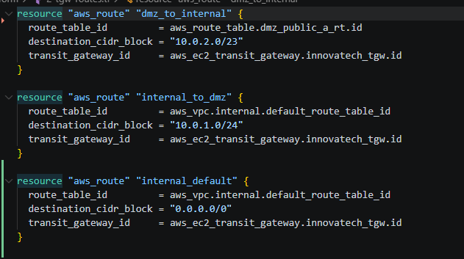
Figure 10: 2-tgw-routes.tf: VPC routes that send traffic through the Transit Gateway

4.2 Outbound Internet Through the DMZ
This part completes the outbound path for internal servers. The Transit Gateway has a default route that sends internet-bound traffic to the DMZ attachment, which lands in the dedicated innovatech-tgw-attach-subnet (10.0.1.192/26). That subnet has its own route table, and its default route points at the NAT gateway. The full path is: internal server → Transit Gateway → attachment subnet → NAT gateway → Internet Gateway. Internal servers can therefore download updates, but nothing on the internet can start a connection to them.
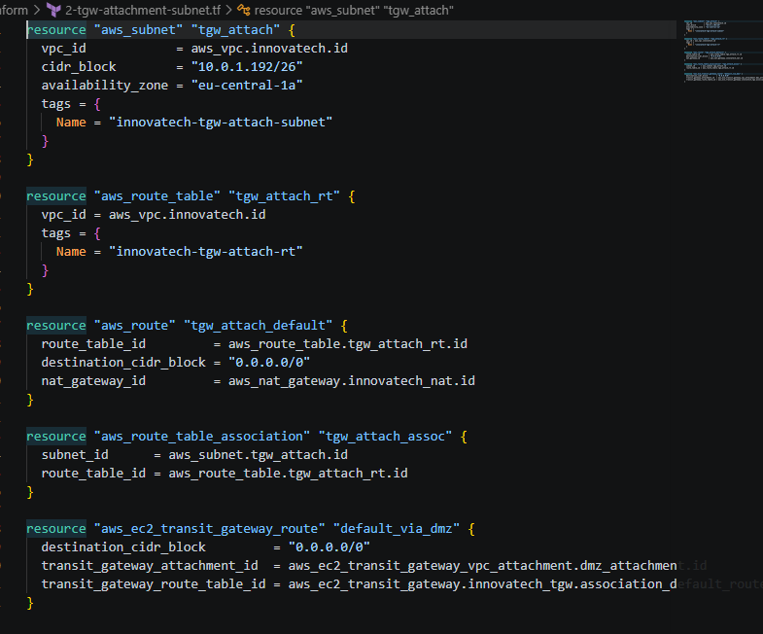
Figure 11: 2-tgw-attachment-subnet.tf: attachment subnet, NAT route and Transit Gateway default route

5. Security Groups
Security groups act as a firewall on each server. Each tier has its own group, and it only accepts traffic from the tier directly in front of it: internet → load balancer → web → database. The monitoring server may also collect metrics from the other tiers.
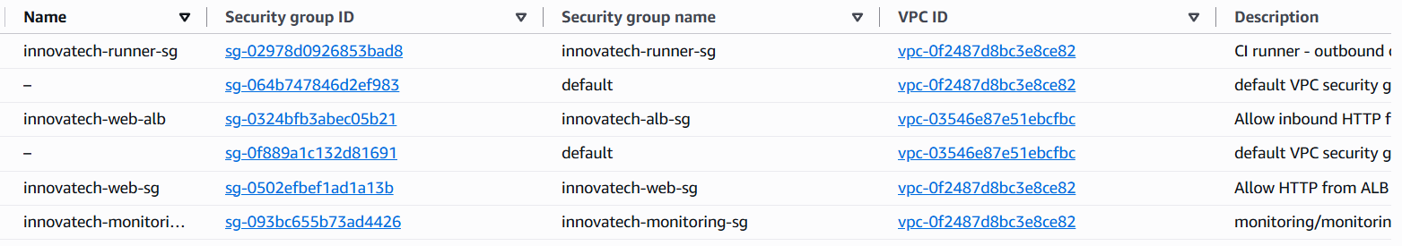
Figure 12: AWS console: deployed security groups in both VPCs

5.1 Load Balancer (ALB)
This is the only security group that accepts traffic from the internet, and only HTTP on port 80. It is attached to the Application Load Balancer in the DMZ VPC.
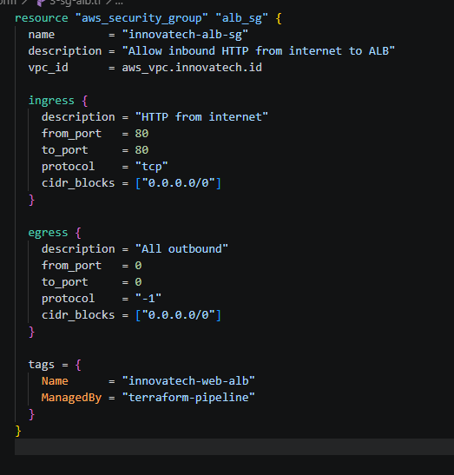
Figure 13: 3-sg-alb.tf: ALB security group

5.2 Web Tier
The web servers accept HTTP only from the two DMZ public subnets where the load balancer runs. They also accept port 9100 from the monitoring security group so Prometheus can collect server metrics. They accept nothing else.
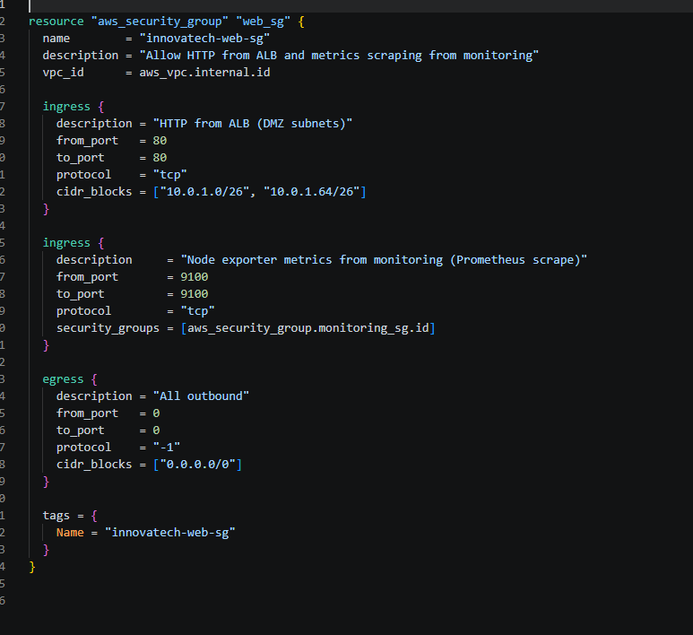
Figure 14: 3-sg-web.tf: web tier security group

5.3 Data Tier
The database accepts MySQL (port 3306) only from the web tier security group. The only other traffic allowed in is the Prometheus metrics port from monitoring. Neither the load balancer nor the internet can reach the database.
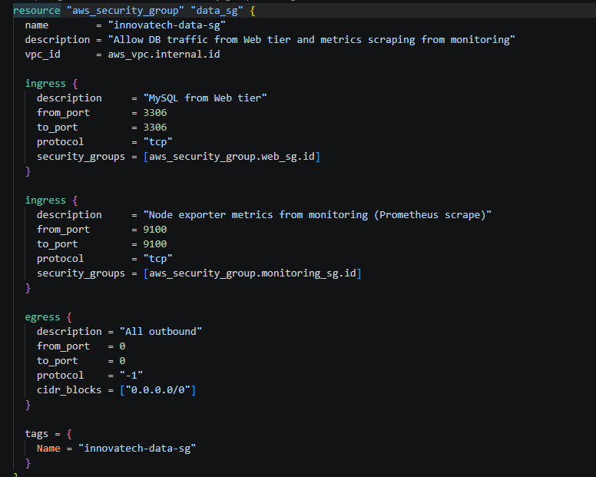
Figure 15: 3-sg-data.tf: data tier security group

5.4 Monitoring Tier
The monitoring server (Prometheus and Grafana) has no inbound rules. Administrators connect through AWS Systems Manager (SSM), and SSM connections start from the server itself, so no ports need to be open to it.
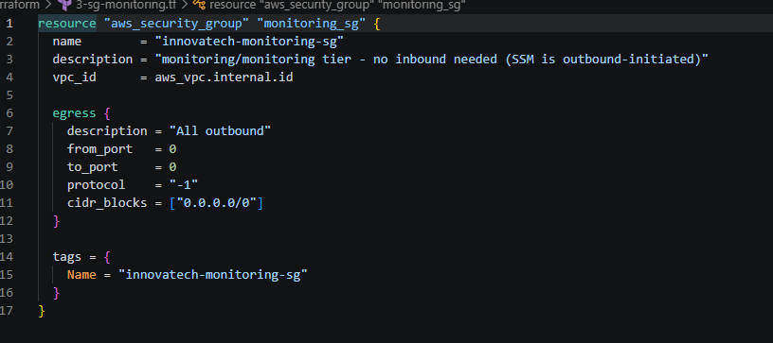
Figure 16: 3-sg-monitoring.tf: monitoring security group

Summary
The screenshots show that the network was built as designed. The DMZ VPC is the only part exposed to the internet. The internal tiers are reached only through the Transit Gateway and the load balancer. Internal servers reach the internet only outbound, through the NAT gateway. Each tier's security group allows only the traffic that tier needs. The whole network is defined in Terraform, and the console confirms that it is deployed.

